**Internship Project - Laravel Hotel Management System**

**ABSTRACT :**

In this article, we introduce a holistic hotel and resort booking system that has been built utilizing PHP programming language and the Laravel framework. The primary objective of the system is to optimize the booking procedure and elevate the management of reservation requests, resulting in an enhanced guest experience and improved operational efficiency. Through the automation of essential tasks and the provision of a user-friendly interface, the system streamlines the reservation process, minimizing errors and ensuring precise booking management. Overall, this system serves to revolutionize the booking experience, increasing efficiency and accuracy while maximizing customer satisfaction.

**OBJECTIVE :**

The main objective of this undertaking is to create a sophisticated and user-friendly booking administration system specifically designed for hotels and resorts. The system aims to establish a centralized platform where guests can effortlessly submit their booking requests, while enabling staff members to effectively oversee and track the status of these reservations. To guide the development process, the following aims have been identified:

* Simplify the Booking Process: The system will feature an intuitive interface that streamlines the search for available rooms, facilitates the selection of desired dates, and enables seamless booking. Clear instructions and prompts will guide guests throughout the process, ensuring accurate capture of all necessary details.
* Enhance the Guest Experience: The system will prioritize improving the overall booking experience for guests. It will incorporate functionalities such as room preferences, special requests, and online payment options to provide a convenient and personalized experience.

By delivering a user-friendly interface and efficient booking management, the system aims to surpass guest expectations and maximize customer satisfaction. By accomplishing these objectives, the Laravel-based booking management system will serve as an invaluable tool for hotels and resorts, promoting efficient reservation management, elevating guest satisfaction, and optimizing overall operational performance.

**INTRODUCTION :**

In the ever-evolving hospitality sector, effective handling of booking requests is crucial to maintain smooth operations for hotels and resorts. Traditional manual booking systems often prove to be time-consuming and prone to errors, leading to dissatisfied customers and potential revenue loss. To address these challenges, a cutting-edge automated booking management system powered by PHP and Laravel has been introduced.

The proposed system revolutionizes the booking process by providing guests with a highly intuitive and user-friendly interface to effortlessly submit their booking requests. It encompasses a wide range of features, including the ability to select a booking name, specify preferred dates, and offer additional preference options. Simultaneously, the system equips staff members with an efficient administrative interface that empowers them to efficiently handle bookings. This interface enables staff to seamlessly view and update reservation details, ensuring accuracy and real-time information.

By implementing this booking management system based on Laravel, hotels and resorts can significantly improve their operational efficiency, reduce errors, and enhance overall customer satisfaction. The system's automation capabilities and intuitive interfaces streamline the entire booking process, benefiting both guests and staff members alike.

**METHODOLOGY :**

The development of the Laravel booking management system adheres to a well-defined methodology, encompassing the following stages.

1. Database Design: The initial phase involves designing the database schema to efficiently store and manage crucial information regarding guests, bookings, web pages, and other pertinent data. Laravel's database migration feature is employed to seamlessly create and modify the database structure.
2. User Interface Development: The system's user interface is crafted using Laravel's blade templating engine, facilitating the efficient rendering of HTML views. The interface incorporates intuitive forms that enable guests to effortlessly submit booking requests and staff members to efficiently manage bookings. These forms undergo validation to ensure the accuracy and integrity of the entered data.
3. Logic Implementation: The system's logic is implemented using PHP and harnesses the built-in functionalities of Laravel. This encompasses handling form submissions, validating input, querying the database, and updating booking statuses. To ensure maintainable code and the separation of concerns, the development adheres to the Model-View-Controller (MVC) architectural pattern provided by Laravel.
4. System Components: The Laravel booking management system comprises a Home Page and two modules for user login and admin login. The Home Page features a navigation bar housing the hotel booking system's icon, along with dynamic pages such as Team, About Us, and Contact Us. It also showcases a carousel displaying images of hotel rooms and options for Buffet Lunch/Dinner/Breakfast. Additionally, there are placeholder images of the hotel's founder, manager, and treasurer. Social media account links for the hotel and key members of the hotel management are also provided. New users have the opportunity to explore the various pages of the website.
5. User Authentication and Registration: Users, including both administrators and regular users, can access the system through the login page using their respective credentials. New users have the option to register themselves via the registration form, which can be accessed through the signup page linked from the login page.

**Admin Login Credentials(arya05012004@gmail.com /secret)**

The Admin Dashboard encompasses a sidebar with sections such as Dashboard, Bookings, Webpages, Users, and Admin Profile. The Dashboard section provides an overview displaying the total number of users, including both admin and client users. It also presents counts for total bookings and completed bookings, as well as the total number of webpages and active webpages. In the Bookings section, the admin can allocate specific rooms to users or update the booking status for individual users. The Webpages section empowers the admin to dynamically add new webpages to the website or modify existing ones. Through the Users section, the admin can maintain a comprehensive record of all hotel users. This section allows the admin to add new users or update the details of existing users as necessary. Lastly, the Profile section contains the admin's personal information. The admin can view and update this section as required, ensuring accurate and up-to-date details.

**User Login Credentials(ameya.madan@gmail.com/secret)**

The User Dashboard features a sidebar with sections including Dashboard, Bookings, and View/Edit Profile. On the dashboard, the user can easily access information regarding the total bookings and completed bookings. In the booking section, users have the ability to add new bookings or update the status of their booked hotels according to their preferences. The profile section allows users to view or make edits to their personal profile details. Both the admin and user can sign out by clicking on the sign-out button located at the top right corner of the dashboard. Upon signing out, they will be redirected to the login/signup page to access the system again.

**CODE (Screenshots of Results And Output) :**

Fig 1

.1

:

Home Page

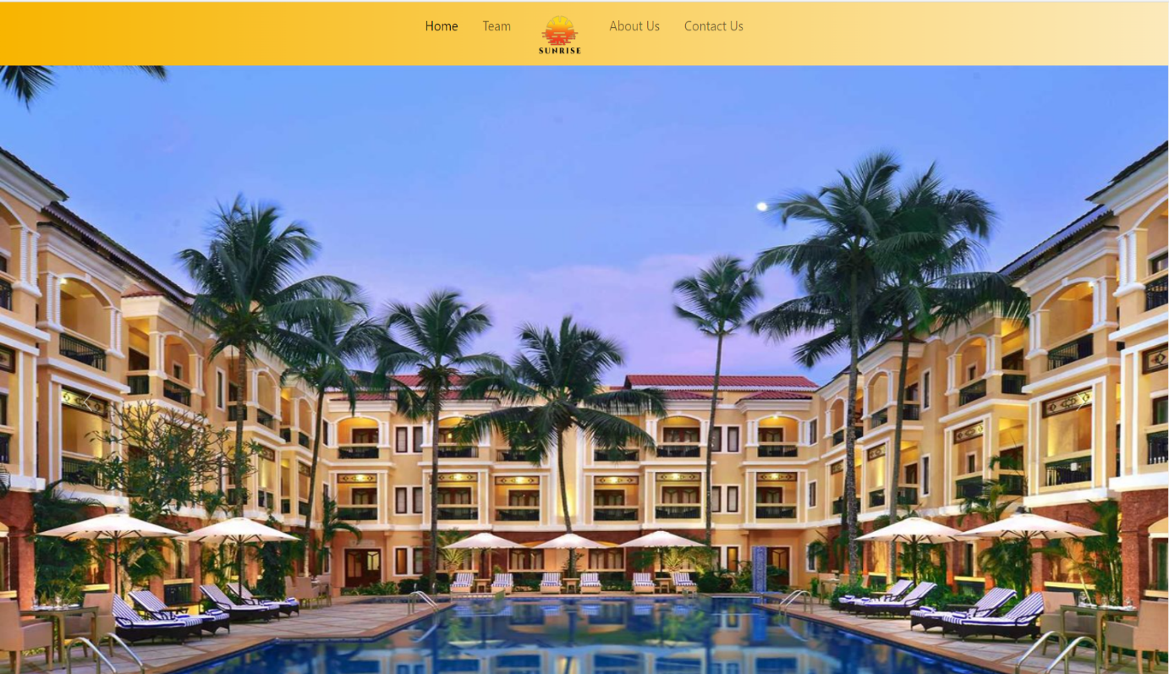

Fig

2

:

Teams

Page

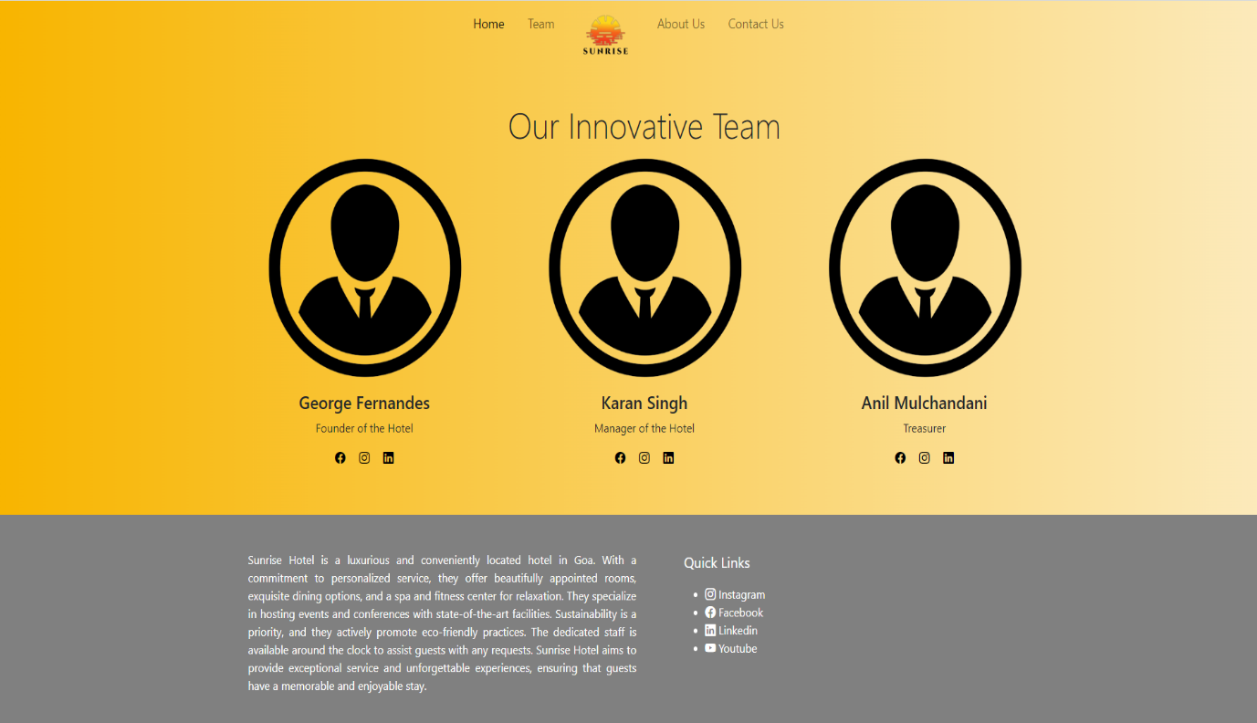

Fig

3

:

About Us

Page

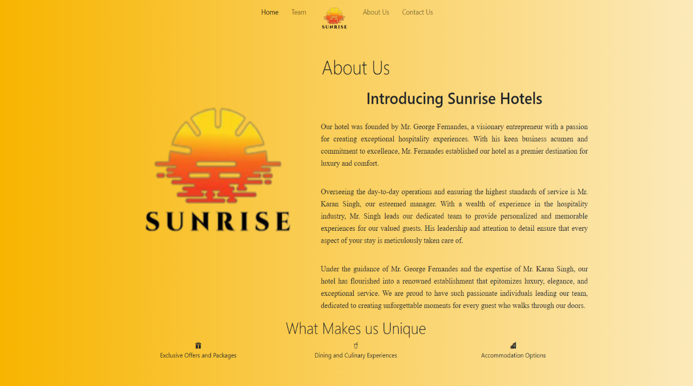

Fig

4

:

Contact Us

Page

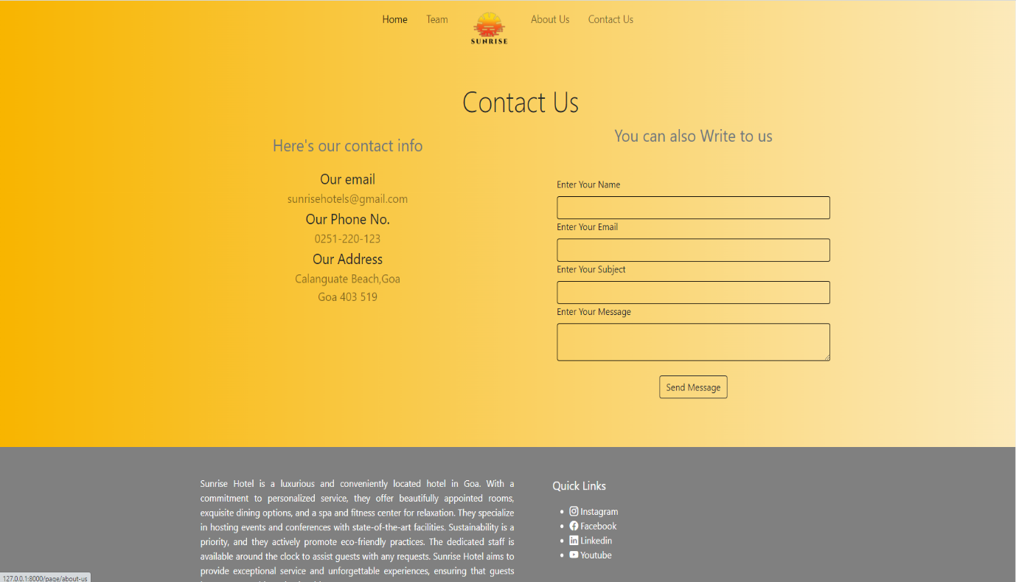

Fig

5

:

Login

Page

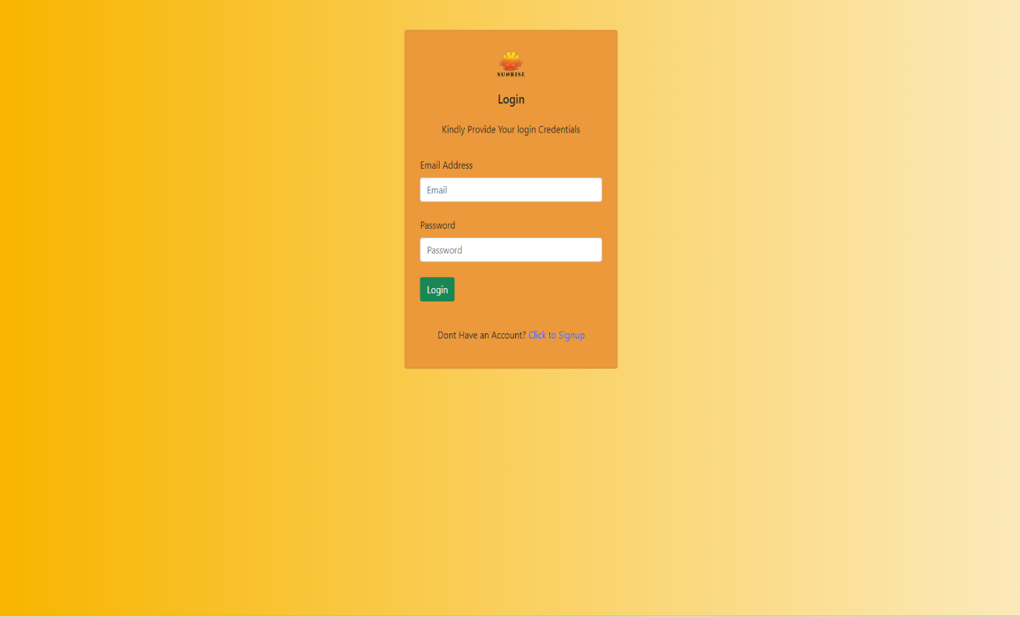

Fig

6

:

Sign up

Page

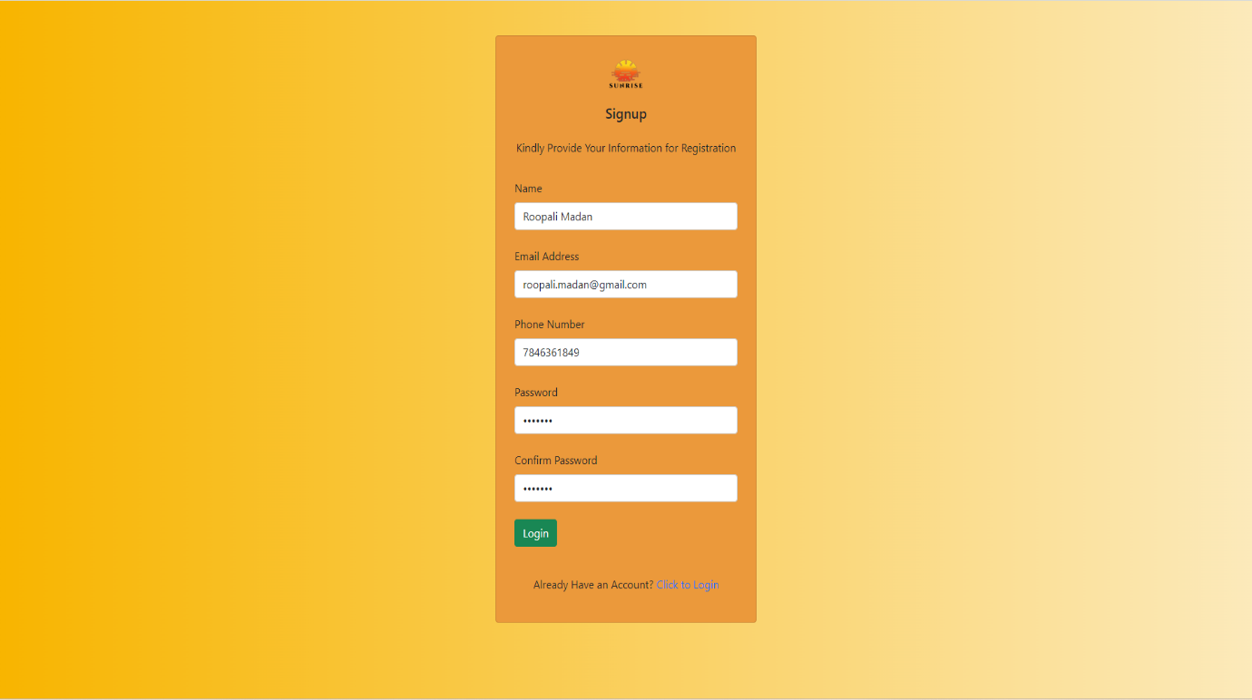

Fig

7.1

:

Admin Dashboard

Page

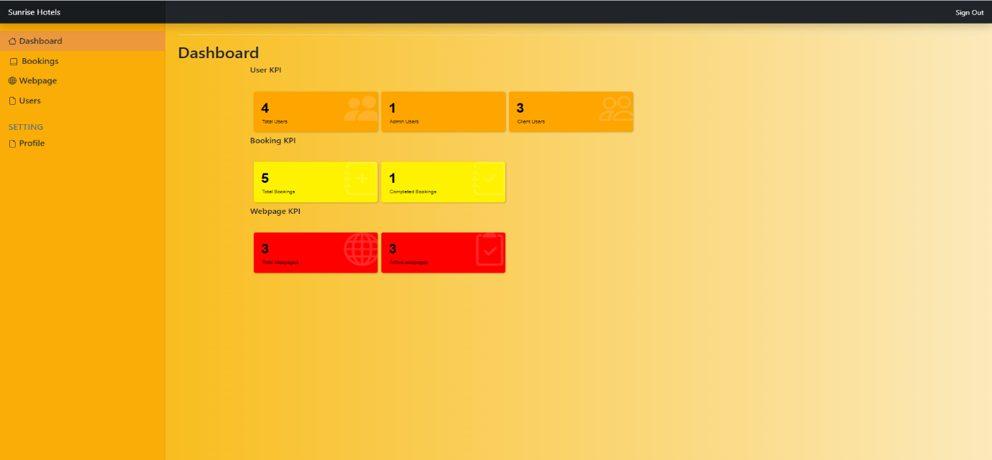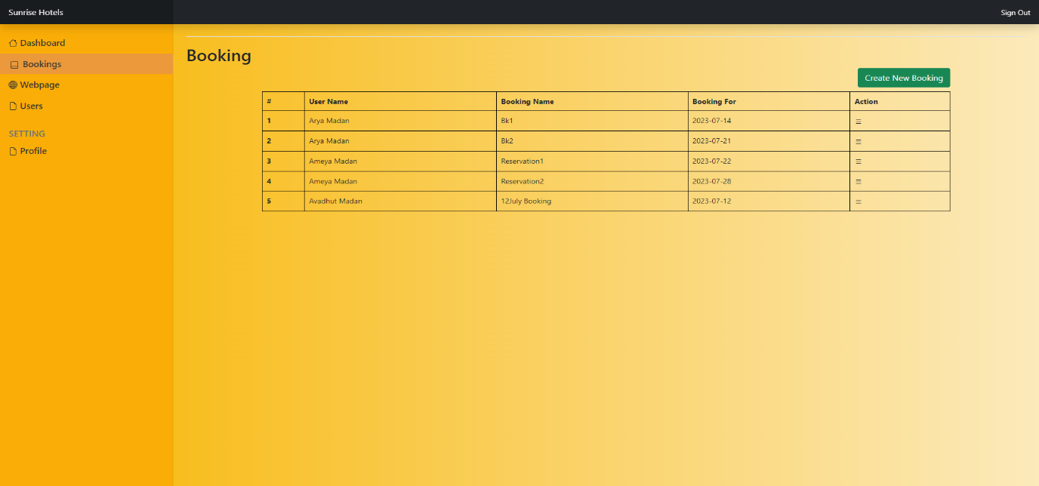

# Fig 7.2.1: Admin Dashboard Page(Booking section show all bookings)

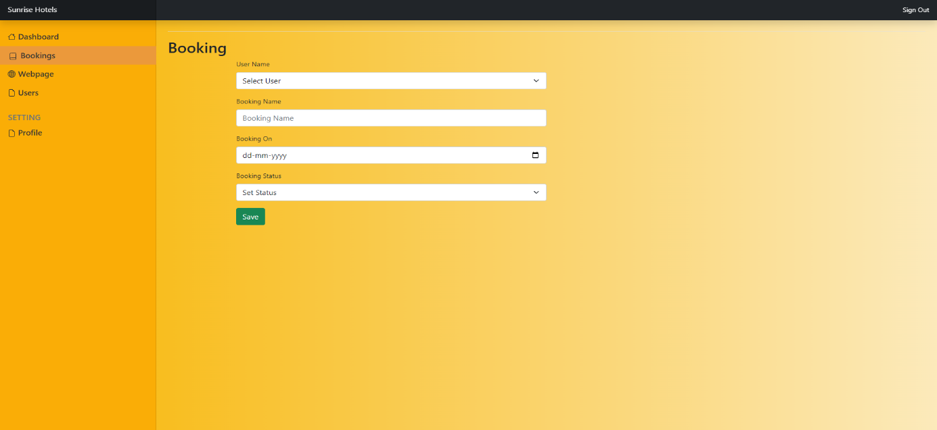

Fig 7.2.2: Admin Dashboard Page(Create new booking)

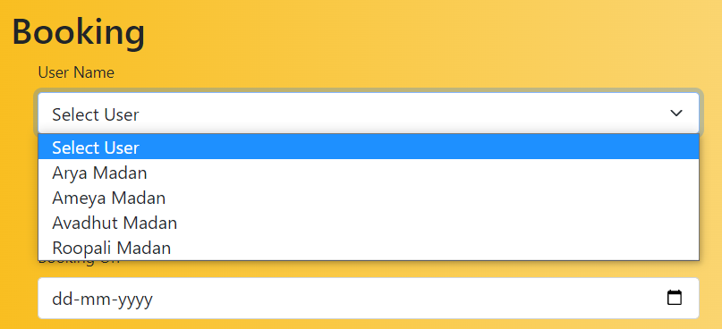

# Fig 7.2.3: Admin Dashboard Page(Create new booking dropdown for user name)

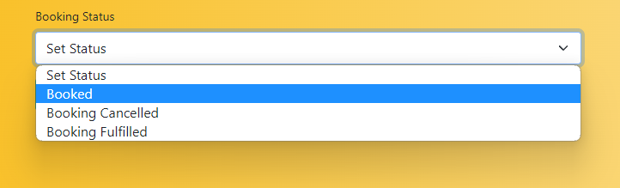

Fig 7.2.4: Admin Dashboard Page(Create new booking dropdown for Booking status)

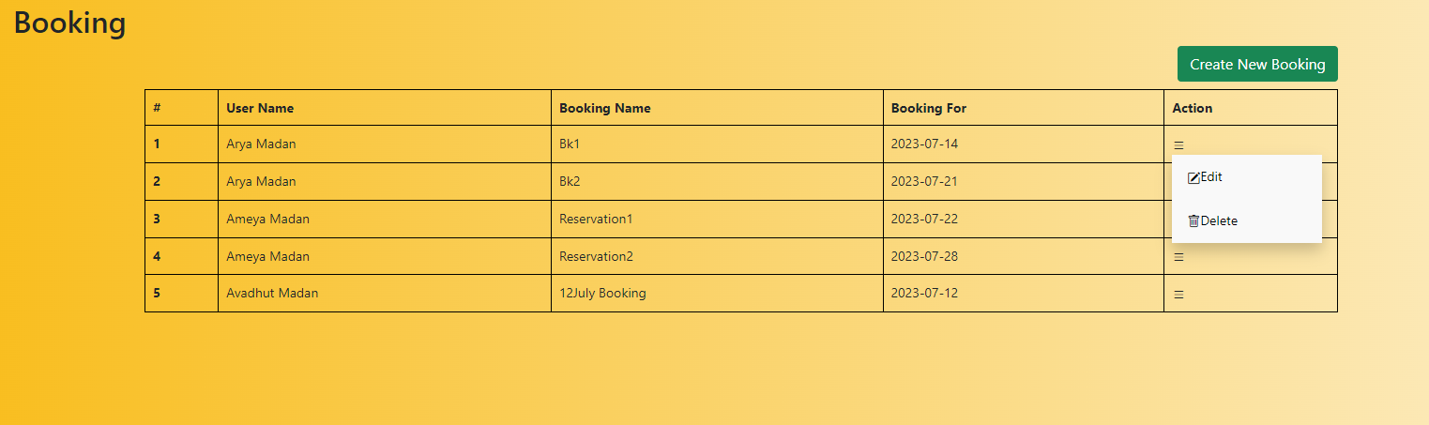

# Fig 7.2.5: Admin Dashboard Page(All bookings edit delete option)

Fig 7.2.6: Admin Dashboard Page(update an existing booking)

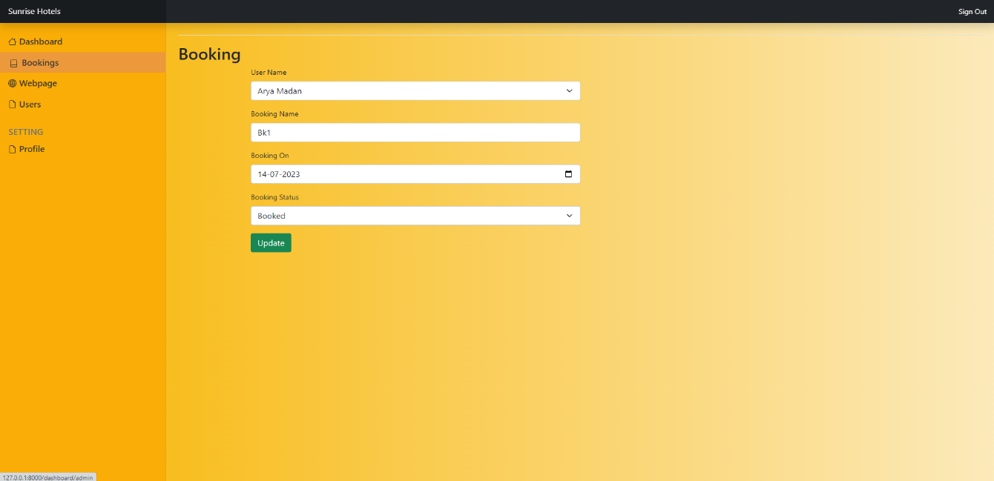

Fig

7.2.7

:

Admin Dashboard Page

(

Delete booking

)

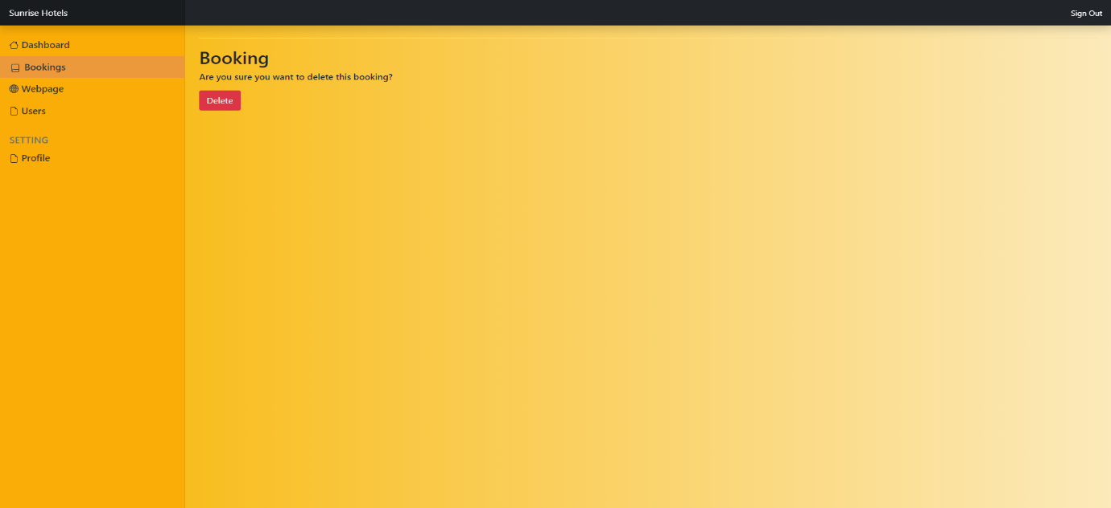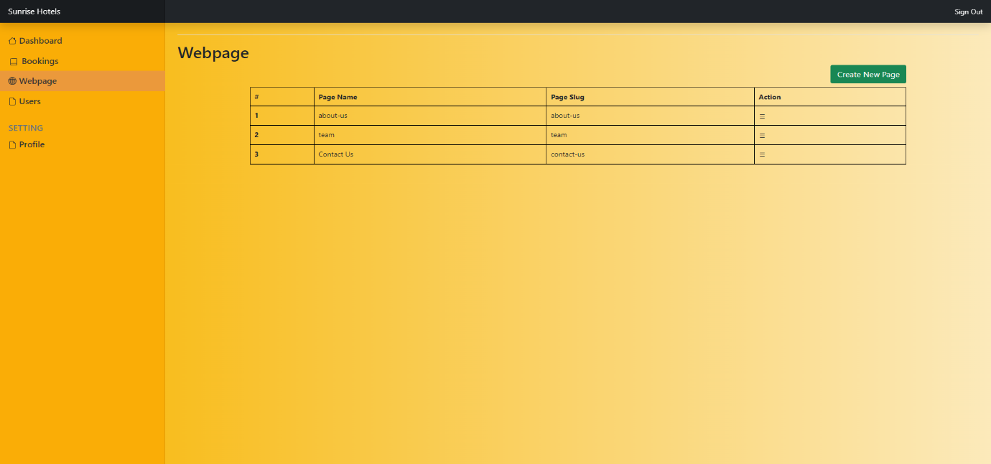

# Fig 7.3.1: Admin Dashboard Page(Webpage section all webpages)

Fig

7.3.2

:

Admin Dashboard Page

(

Add a webpage)

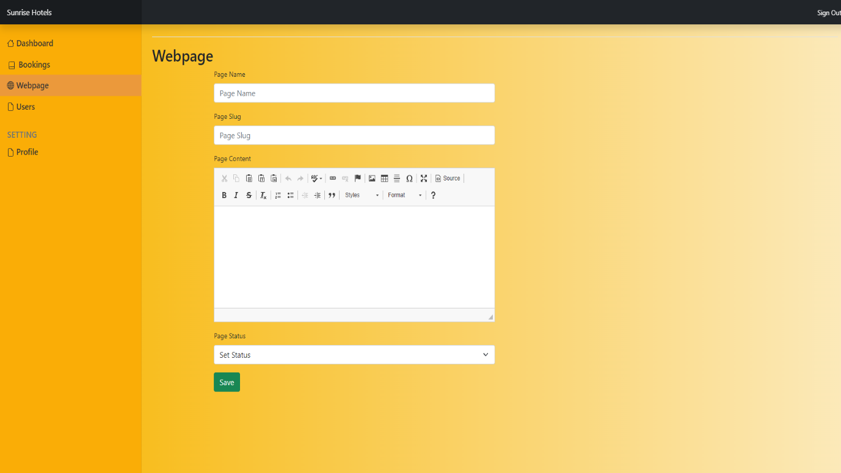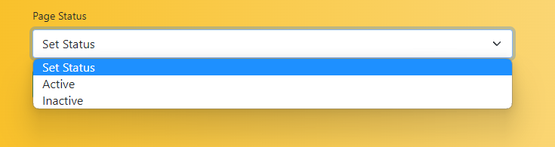

# Fig 7.3.3: Admin Dashboard Page(Add a webpage Dropdown for status of webpage)

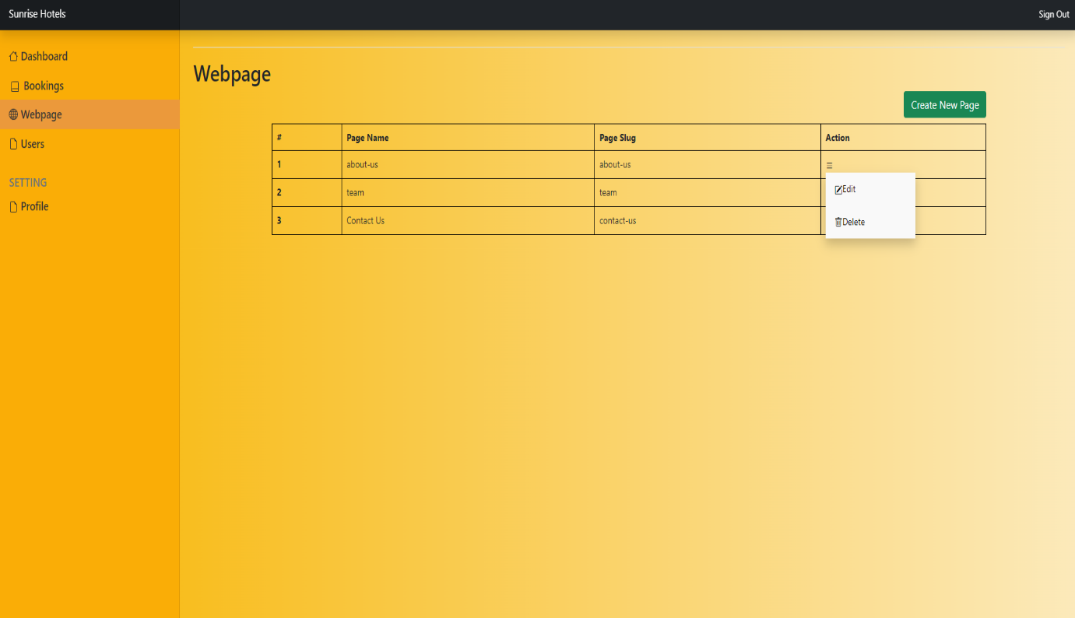

Fig 7.3.4: Admin Dashboard Page(Edit or delete option for webpage)

Fig 7.3.5: Admin Dashboard Page(Edit option for webpage)

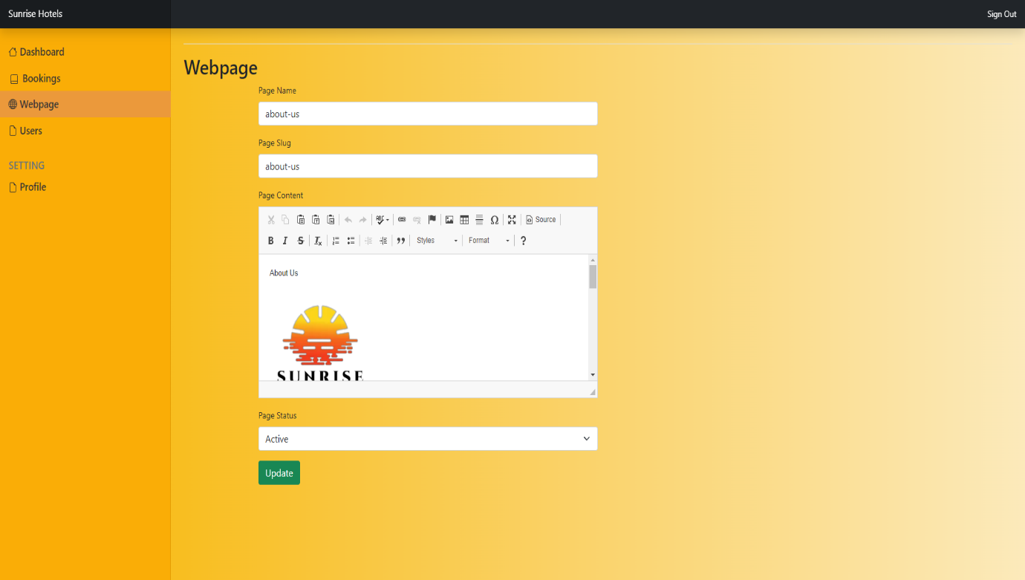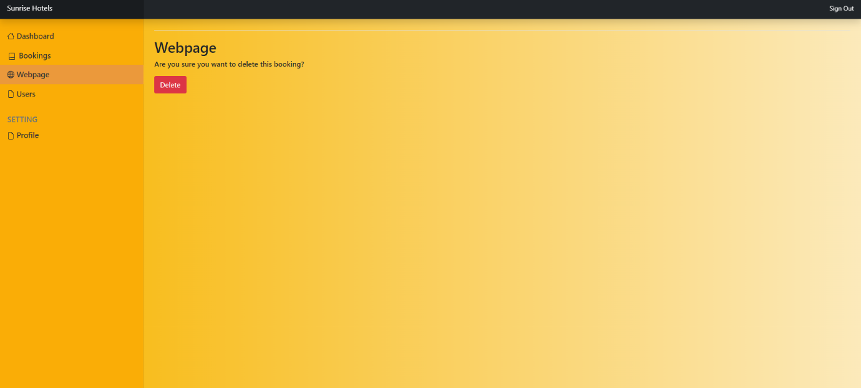

# Fig 7.3.6: Admin Dashboard Page(delete option for webpage)

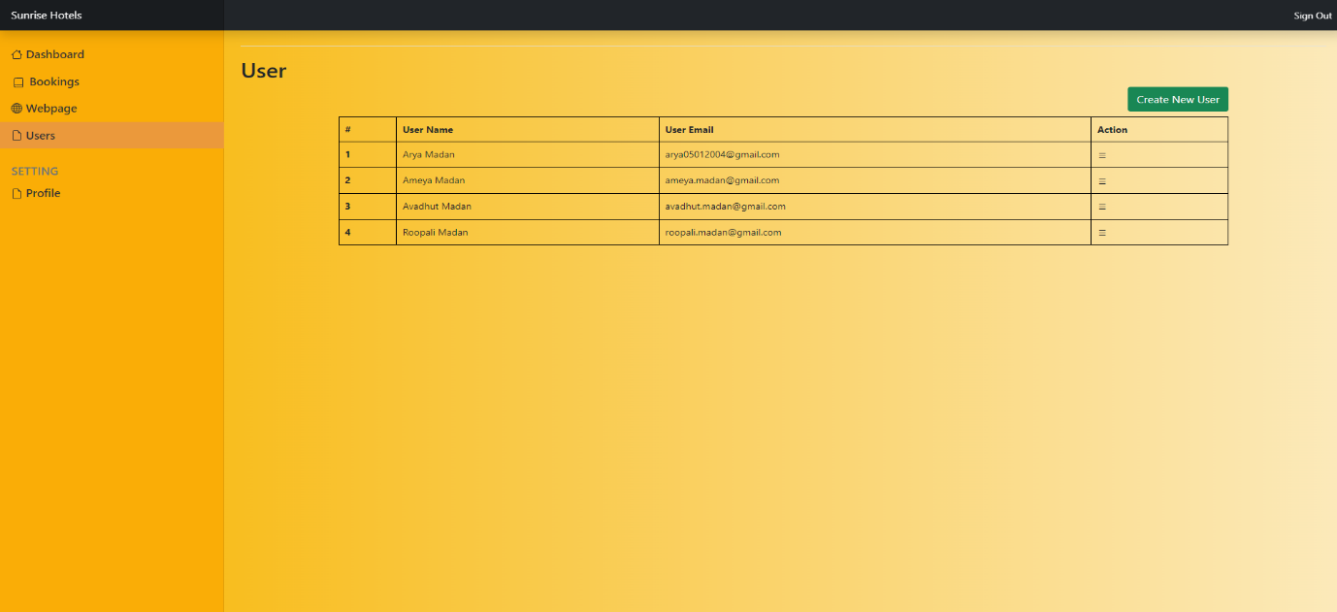

# Fig 7.4.1: Admin Dashboard Page(User section display all users)

Fig

7.4.2

:

Admin Dashboard Page

(

Create new user

)

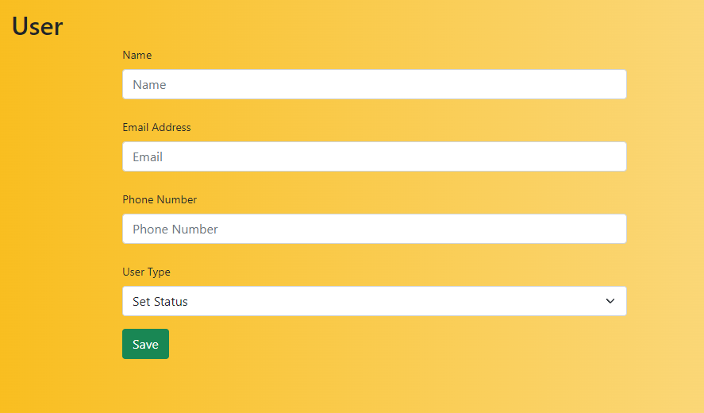

Fig 7.4.3: Admin Dashboard Page(Create new user status dropdown)

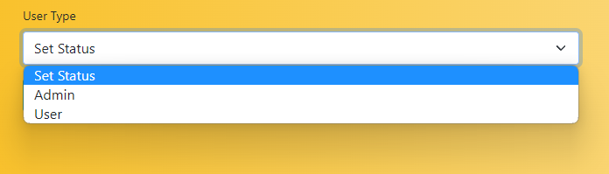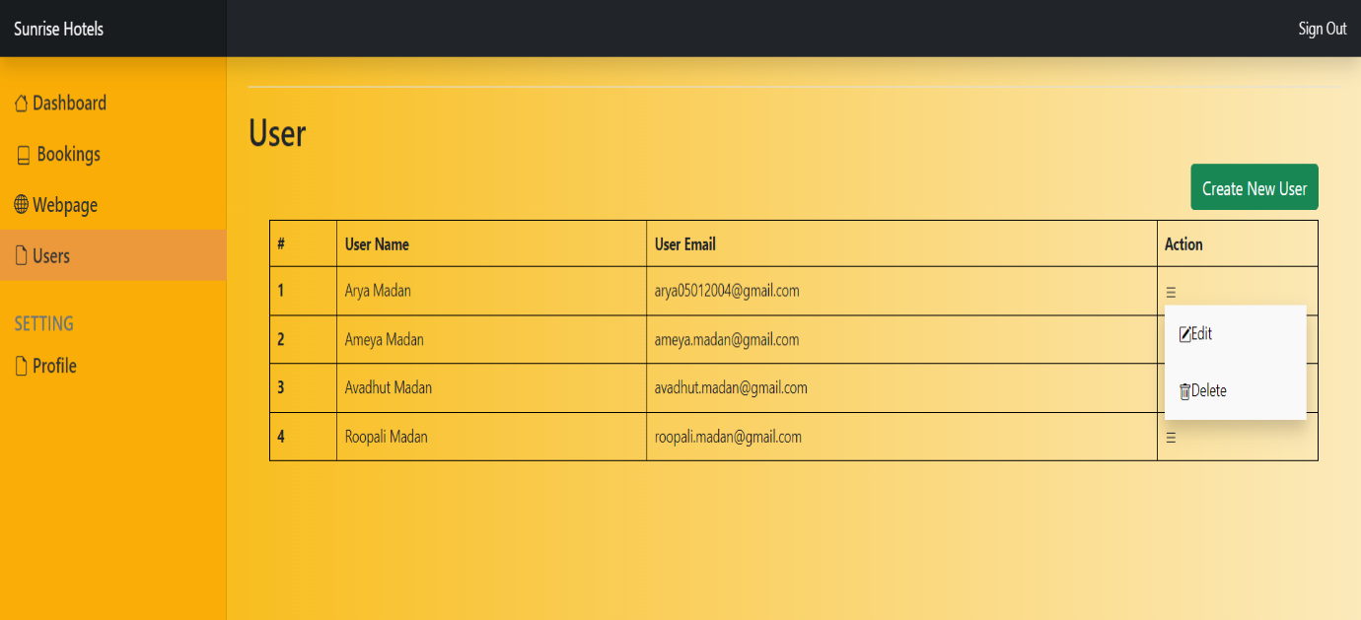

Fig 7.4.4: Admin Dashboard Page(User section edit or delete option)



# Fig 7.4.5: Admin Dashboard Page(User section edit option)



# Fig 7.4.6: Admin Dashboard Page(User section edit option status dropdown)

Fig

7.4.7

:

Admin Dashboard Page(User

delete

)

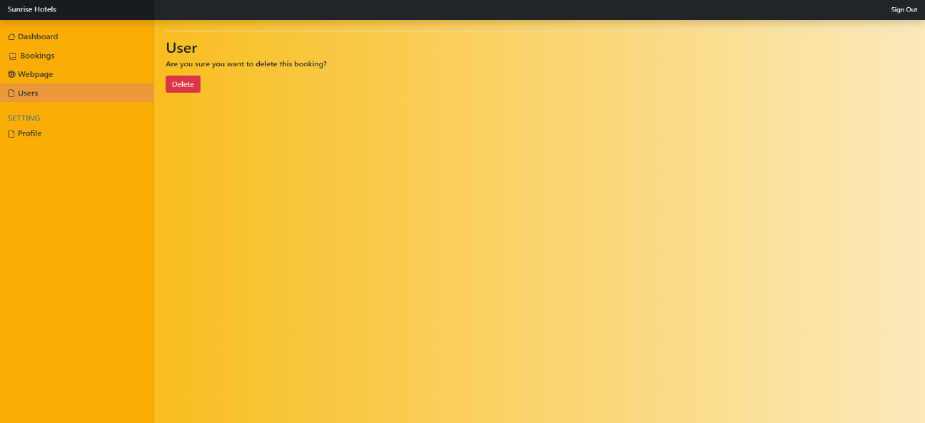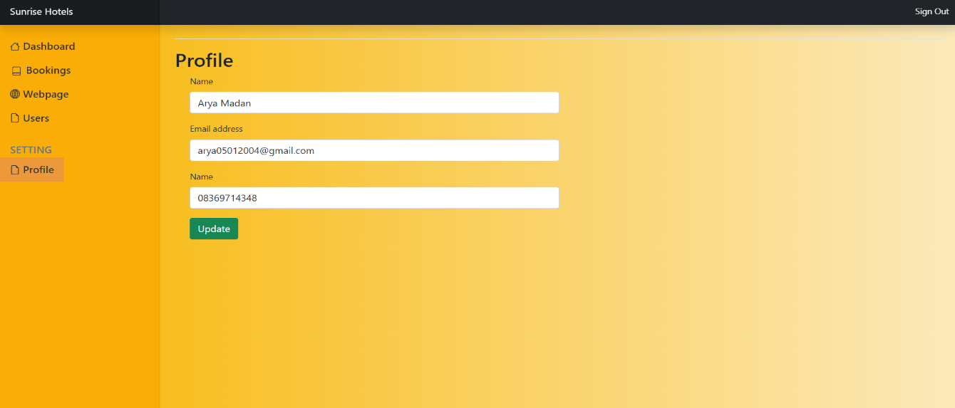

Fig 7.5: Admin Dashboard Page(Admin Profile)

Fig

8.1

:

User

Dashboard Page(

User Dashboard

)

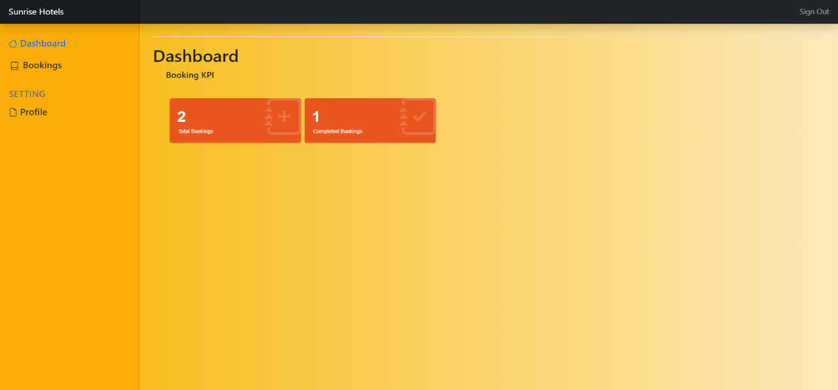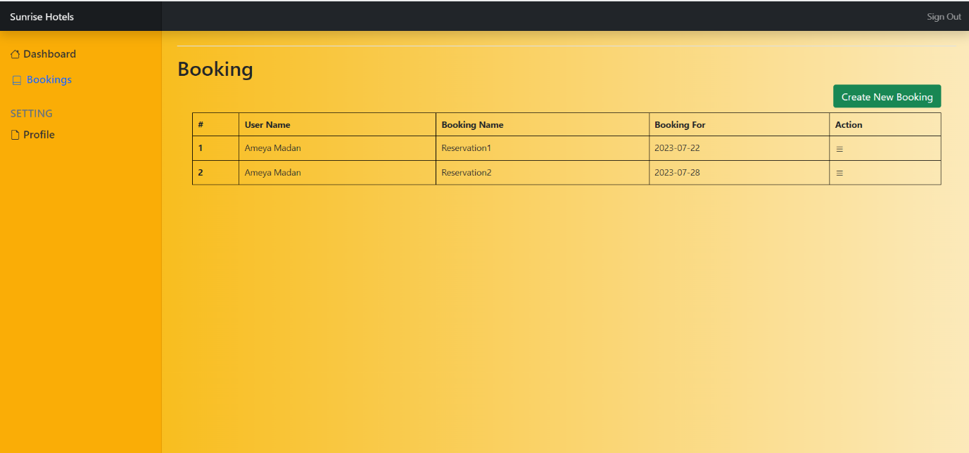

Fig 8.2.1: User Dashboard Page(User section All bookings)

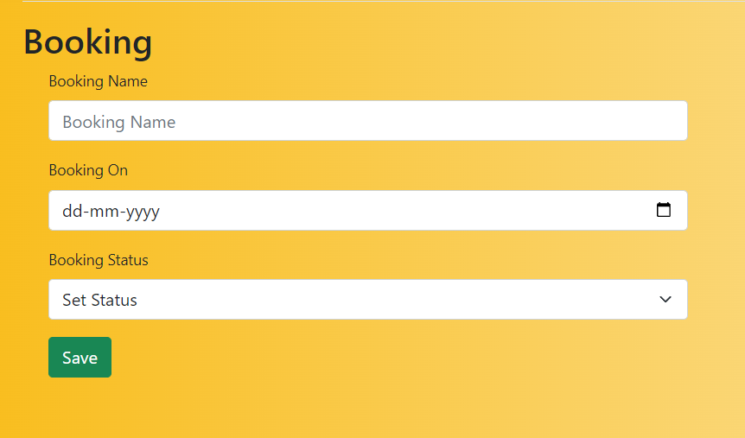

# Fig 8.2.2: User Dashboard Page(User section new booking option)

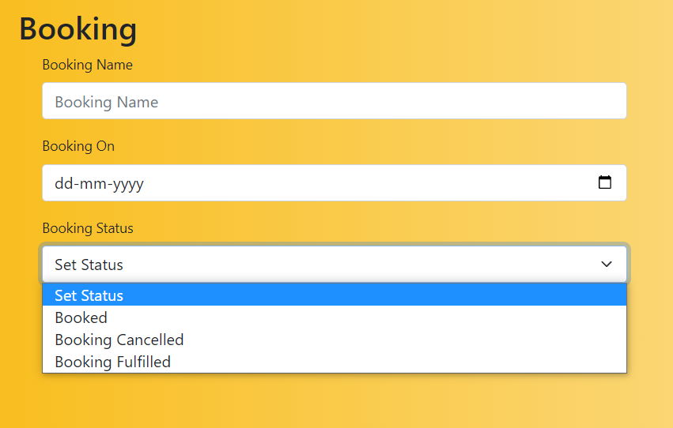

Fig 8.2.3: User Dashboard Page(User section new booking option dropdown for booking status)

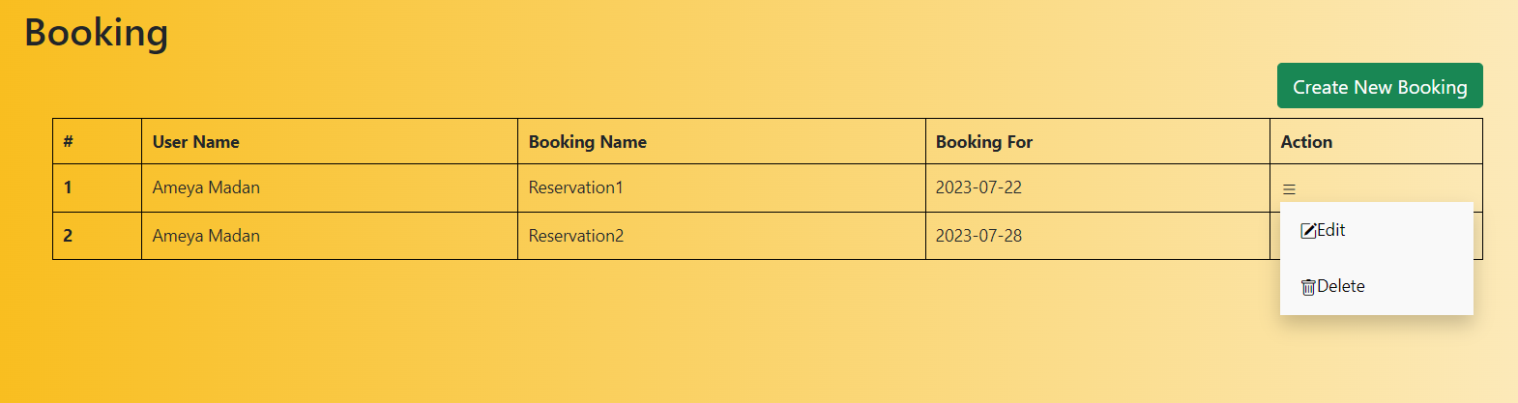

# Fig 8.2.4: User Dashboard Page(User section all booking edit or delete option)

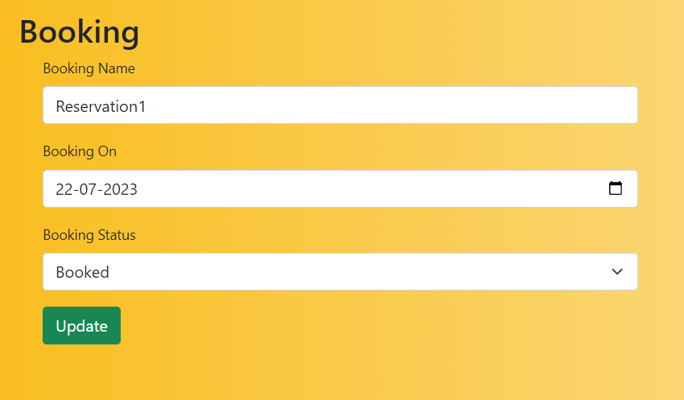

Fig 8.2.5: User Dashboard Page(User section all booking edit option)

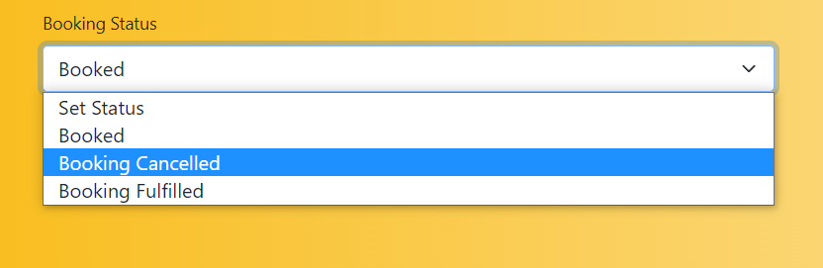

# Fig 8.2.6: User Dashboard Page(User section all booking edit option status dropdown)

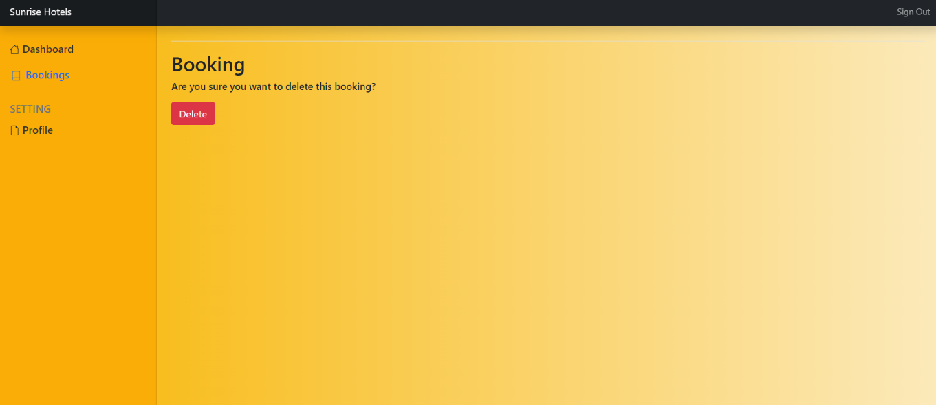

Fig 8.2.7: User Dashboard Page(User section delete booking option)

Fig

8.3

:

User

Dashboard Page(User section

Profile

)

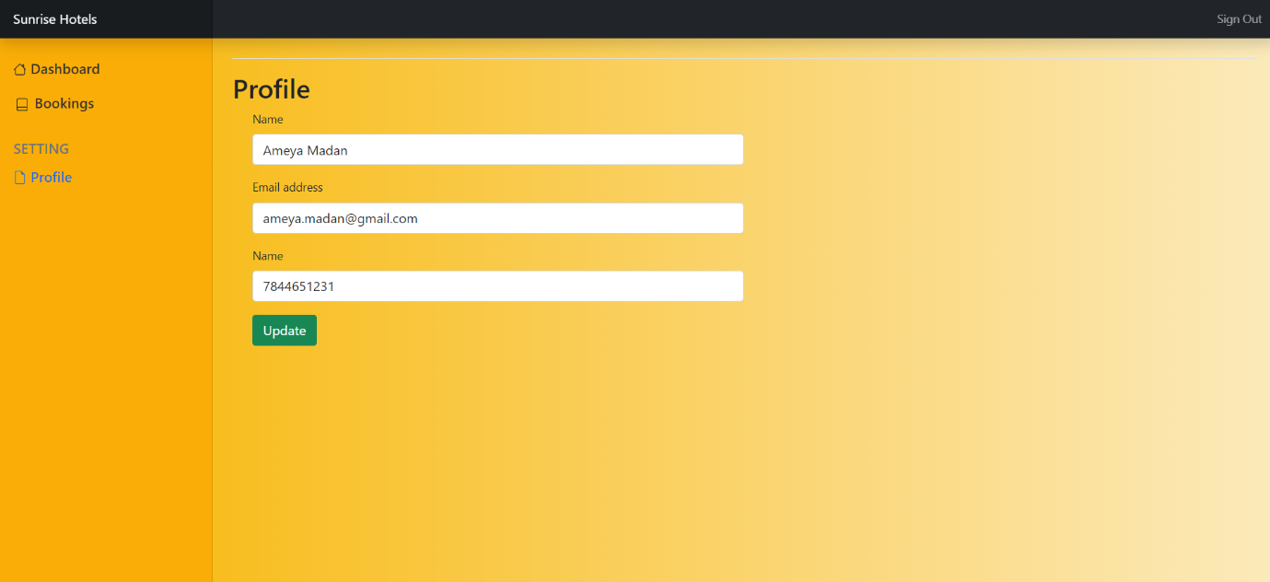

**CONCLUSION :**

The booking management system built on the Laravel framework offers a reliable and efficient solution for managing booking requests in the hospitality industry. This system brings a paradigm shift to the booking process, leading to improved precision and heightened customer contentment. By automating essential tasks, it effectively lightens the workload on staff, allowing them to devote more time to providing exceptional service to guests. With its intuitive user interface and extensive features, this system proves to be the ideal choice for hotels and resorts looking to enhance their booking management capabilities and reach new levels of excellence.